

TMDB TV Show Database – ML Project
BIU DS20 Data Science Course
Author: Yonatan Umansky

1. Overview
The TMDB database contains information on over 150,000 TV shows across all years, genres, and regions. Each record includes valuable details such as spoken languages, genres, creators, networks, and more.
The target variable in this project is TV show popularity — a proprietary TMDB measure representing a show's overall success. Although the exact formula is undisclosed, it is known to be based on a combination of engagement metrics, such as:
- Number of votes cast for the show
- Number of users who marked it as a favorite
- Number of users who added it to their watchlist
- Number of times the show was accessed
- Other platform engagement metrics
The primary goal is to build a robust regression model to predict a show's popularity level, leveraging existing features and newly engineered ones.

2. Dataset Description
The dataset consists of 160K TV show records with multiple categorical and numerical attributes. Below is a snapshot of its key structure:

3. Main Project Steps and Methodology
The project followed a standard Machine Learning pipeline, with specific focus on data cleaning and feature engineering due to the nature of the raw data.

3.1 Data Preparation
The primary challenges were a high percentage of missing values (NaNs) in key columns and multi-value features (e.g., a show having multiple genres).
- Handling Missing Values:
  - API Augmentation: Missing values for key features were partially recovered by querying the TMDB's API directly, as the raw data file was not fully up-to-date.
  - Dropping Unrecoverable Data: Features with an excessively high percentage of unrecoverable NaNs (e.g., tagline, homepage) and technical URL fields were dropped.
- Handling Multi-Value Features (e.g., genres, languages):
  - Values were first split, then consolidated into more generic categories to manage high cardinality.
  - A Multi-Hot Encoding approach was chosen during the encoding phase to create multiple binary columns, correctly capturing that a single show can belong to more than one category (e.g., 'Action' and 'Drama').
- Data Transformation: Features were converted to appropriate formats (int, binary, float) for modeling.

3.2 Exploratory Data Analysis (EDA)
The EDA focused on identifying relationships between features and the target variable, popularity.
- Analysis Methods: Distribution plots, correlation heatmaps for numerical features, and statistical significance tests.
- Statistical Tests: T-Tests and ANOVA were performed to check if the average popularity varied significantly across different categorical groups.
- Key EDA Conclusions:
  - The target variable, popularity is highly skewed.
  - ANOVA confirmed statistically significant differences in average popularity for groups within the following features: TV show genre, TV show type (Scripted, Documentary, etc.), regional origin, and original language.
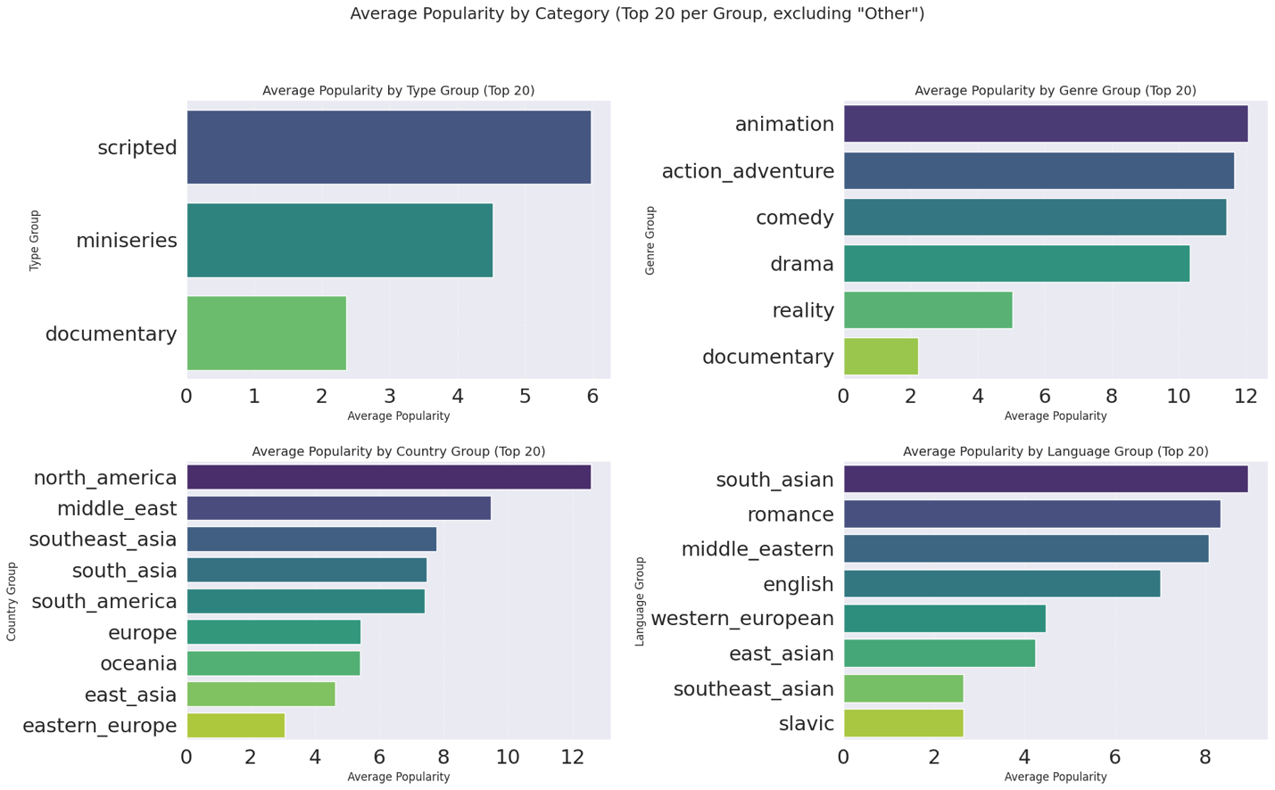
  - No significant apparent correlation was found among the original numerical features (e.g., episode run time, number of seasons).

3.3 Data Outliers Treatment
Given the highly skewed nature of the target variable and the unknown exact calculation of popularity, outlier treatment was critical.
- Method: Outliers were detected using Box Plots and the Interquartile Range (IQR) method.
- Action: Detected outlier records were subsequently deleted and imputed using the MICE (Multiple Imputation by Chained Equations) method.

3.4 Feature Engineering and Selection
The original TMDB data contains important categorical and numerical features. The original list of features, however, is still limited only to basic and raw type of features and I found it necessary to expand the list by adding a few calculated measures of my own. They include:
- Date-based features such as a show’s tenure in years, and a measure of average season per year based on that tenure
- Other numerical measure, such as: a binary feature to indicate whether a show is available other than in the English language? Or how many different languages is a show available with?
Feature Encoding:
Since most of the categorical data in TMDB is not binary, there was a need to transform the categorical values to numerical ones, and the approach I chose for that purpose was to perform ‘one-hot’ and ‘multi-hot’ encoding. A standard label encoding would be risky as it assumes that the categorical values have an inherent order of importance. In our data, there is no such order of importance for the categorical features, therefore I chose the ‘one-hot’ and ‘multi-hot’ encoding approach.
This approach was implemented in the following manner:
- For categorical features which contain only one value per record, I performed a ‘one-hot encoding method
- For categorical features which contain more than one value per record (a list), I performed a ‘multi-hot’ approach which in essence enables a show record to be given a binary indication of ‘1’ for more than one column, this according to the list of values which exist for the record
- For features with a very long list of possible values, I also added a frequency encoding which allowed me to focus on the most important and frequent values for that category
Feature Selection:
Given that after performing our categorical encoding we will have a long list of binary features, it was necessary to perform a feature importance test which would enable us to focus on the most important features when running the regression model later. This is an important step on our way to finding the best model for our scenario.
My strategy for selecting the most important features was to execute importance test using the following models:
- Ridge
- Lasso
- SVR
- Gradient Boost
- Random Forrest
After summarizing the importance as tested by each method, I took only the features which returned the highest total number of importance counts.

3.5 Model Selection and Evaluation
Since the target variable (popularity) is continuous, a Regression approach was chosen.
Data was first split to Train / Dev / and Test segments with the following distribution:
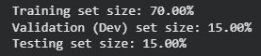
Here is a comparison of the model performance metrics:

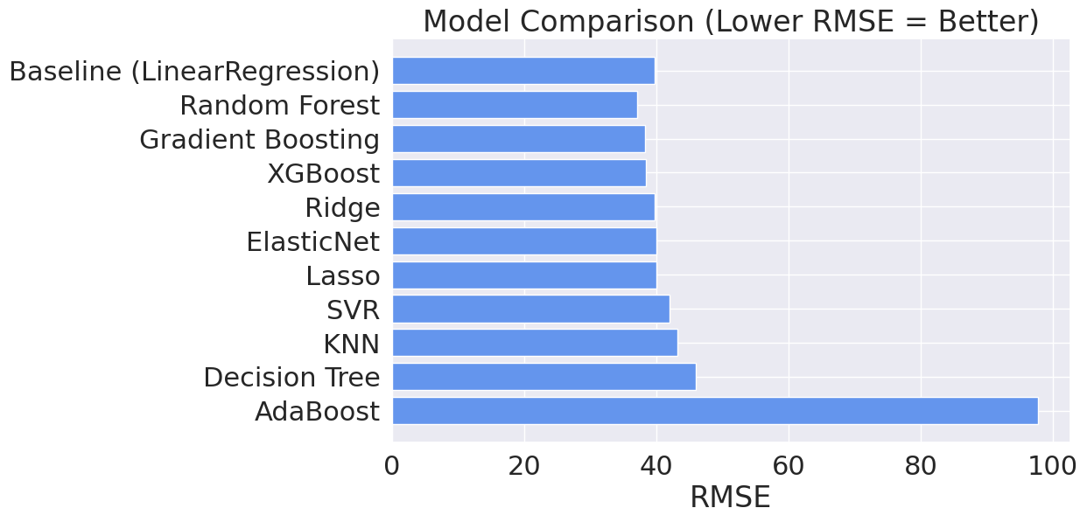
It is apparent that there are no significant differences between the results of the additional regression models and the baseline regression model.
Nevertheless, the Random Forest Regressor was selected as the final model due to its best performance across all key metrics: lowest RMSE and highest R² (0.258).

3.6 Model Fine-Tuning
In order to fine-tune our selected Random Forrest Regressor model with the best available parameters for the best model outcome, I performed the Randomized Search and Grid Search methods with several parameters.
The final combination of parameters using both test methods produced the following outcome:
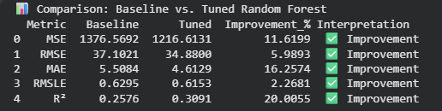

4. Summary and Future Outlook
While the fine-tuned Random Forest model showed improvement, the overall ability to accurately predict a show's popularity remains limited (final R² is low).
This limited performance is likely attributable to inherent data challenges:
- Highly Skewed Target Variable: The nature of the popularity metric itself is a major challenge for standard regression.
- Missing Data: Despite extensive efforts (including API calls) to impute values, a high percentage of missing values persisted in several key categorical features.
- Feature Limitations: The TMDB database lacks crucial features that would likely be strong predictors of success, such as:
- Production cost/budget.
- Key cast members/director names.
- Initial pilot rating or market testing data.

5. Deployment Potential
The TV show business is indeed a thriving industry these days, with scores of new shows being introduced daily in the different streaming and TV services.
A comprehensive database containing a rich variety of characteristics for a wide array of show genres, over a long period of time, is a key contributor to having a model which would be able to predict the probability of a show being successful over time.
The TMDB database is a comprehensive one with the necessary basic elements for such a regression model.
I am confident that once the database contains fewer missing values and possibly additional measures that could indicate a show's level of success, the regression model itself will become much more useful and will provide valuable outcomes.
As for the model deployment, I believe that such a model could be integrated within show production companies' databases as an assisting tool to predict whether an ongoing or new show production could be beneficial to the network.
Once deployed, the model could be updated daily with new shows data and re-calculate the best scenario accordingly.

